Humanities, Arts & Social Sciences Research Seminar

9.30-10.30am Friday 26 July 2019

Megan Daniels presents

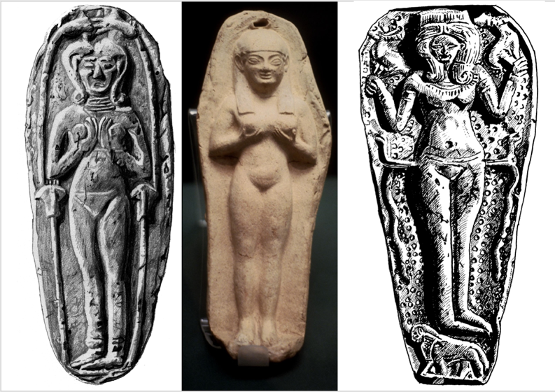
Centre: “Goddess Astarte in ritual pose and gesture; moulded terracotta plaque discovered at the Punic colony of Tharros on Sardinia.” http://quod.lib.umich.edu/a/aict/x-ne233/ne233. University of Michigan Library Digital Collections. Left and right: drawings by Paul Butler 2014

Mothers, prostitutes, or sex goddesses? Rethinking naked female figurines in Iron Age Mediterranean sanctuaries

The iconography of the nude female in the ancient world spans an area from Iraq to Spain over a period of more than 2000 years. It emerged within Mesopotamia in the third millennium BCE, and spread across western Asia in royal, domestic, and funerary contexts. In the Greek world, this imagery appeared between 800 and 600 BCE, a time known as the “Greek renaissance” following the Bronze Age collapse. Modern-day scholars highlighted this period as a time when the Greeks looked to the more venerable Near East for artistic inspiration, the so-called Orientalising period, and explained the nude female through the lens of Orientalism. Scholars working in the Near East and Egypt, on the other hand, explained this imagery through recourse to a generic “fertility/mother goddess” and through misogynistic attitudes towards female nudity. In this presentation I examine how the Orientalising and fertility paradigms have coloured our interpretation of this imagery. I offer a new interpretation that attempts to move beyond artistic influence and generic fertility deities and into the realm of the shared ideologies between Greece and western Asia represented by this imagery. In doing so, I blur distinctions between “west” and “east” and reconsider the shifting relationships between humans and their gods in the Iron Age.

Megan Daniels is a lecturer in Classics and Ancient History in the School of HASS, teaching ancient Greek language and Near Eastern and Egyptian history. Her research interests span Greece and the Near East, stretching from the Late Bronze Age to the rise of the Roman Empire, and focus on the intersections of religion, social complexity, economies, and political ideologies. She is currently working on a monograph on shared ideologies of divine kingship between Greece and the Near East. Further interests are reflected in two volumes of essays she is editing: one on data science and social sciences approaches to ancient religion and another on the interdisciplinary study of migration and mobility.
Oorala lecture theatre, Oorala centre
Followed by morning tea - all welcome
Enquiries to: Karin von Strokirch - kvonstro@une.edu.au

